

LOG Request

Requirement Document

**Version 1.0**

|  |  |
| --- | --- |
| ***Corporate Office & Development Center*** | ***Offshore Development Center*** |
| *5 Concourse Parkway*  *Suite 3200, Atlanta, Georgia 30328*  *Tel 678.281.2014*  *Fax: 678.281.2019* | *Plot # 122 & 123, N.S.E.Z, Phase -2*  *NOIDA, UP 201 305*  *India*  *Tel: 91.11.91.2510483* |

|  |  |  |  |  |
| --- | --- | --- | --- | --- |
| **Author** | | | | |
| **Name** | **Role** | **Date of Preparation** | **Signature** | |
| Evelyn Yap | Project manager | 19-Jan-2015 | Evelyn | |
| **Reviewer(s)** | | | | |
| **Name** | **Role** | **Date of Review** | **Signature** | |
| Pravesh Kumar | Manager Projects |  |  | |
|  |  |  |  | |
| **Approver** | | | | |
| **Name** | **Role** | **Date of Approval** | **Signature** | |
| ChengChoon Yip | VP Ebix Exchange  Asia |  |  | |
| **Document Path** | **Version Number** | **Date of Release** | | |
|  | 1.00 | 19-Jan-2015 | | |
| **Revision History** | | | | |
| **Version Number** | **Date of Release** | **Section/ Page # Changed** | | **Details of Changes** |
| 1.00 | 19-Jan-2015 | All | | Document created |

|  |  |  |
| --- | --- | --- |
| **References** | | |
| **Document** | **Date Received** | **Author** |
|  |  |  |

Contents

2. Overview 3

**a.** Module 4

**b.** Development Type 4

3. LOG 4

2. LOG With Cancellation Clause for Previous LOG 6

3. Rule 9

4. Implementation 10

4.1 Current Implementation 10

4.2 Targeted Implementation 10

5. Change Required 10

# Overview

|  |  |  |  |
| --- | --- | --- | --- |
| ☒ | New | ☐ | Change Request |

* 1. Module

|  |  |  |  |  |  |
| --- | --- | --- | --- | --- | --- |
| ☐ | Diary | ☐ | System Admin Module | ☐ | Claim Registration |
| ☒ | Claim Payment | ☐ | Claim Recovery | ☐ | Claim Enquiry |
| ☐ | Upload | ☐ | Reports |  |  |

* 1. Development Type

|  |  |  |  |  |  |
| --- | --- | --- | --- | --- | --- |
| ☒ | Functionality | ☒ | Integration | ☐ | Rule |
| ☐ | Report | ☒ | Field | ☒ | Screen |

# LOG

|  |  |  |  |  |  |  |
| --- | --- | --- | --- | --- | --- | --- |
| **Form name** | LOG | | |  |  |  |
| Description |  | | | Fields are same as "LOG with cancellation clause for previous LOG" form | | |
| s.no. | Field number as per screen | Field names | screen Name | screen field name | EBIX Remarks | CDGI Remarks |
| 1 | F-1 |  | Unknown | Unknown | Hospital Name | Additional field or tab for user to select which hospital or clinic claimant has visited Drop down field for user to select which hospital or clinic? |
| 2 | F-2 |  | Unknown | Unknown | Hospital Address |
| 3 | F-3 |  | Unknown | Unknown | Name and Email Address of Hospital Representative | To change the template to "Attn: Business Officer" |
| 4 | F-4 |  | Unknown | Unknown | Name and Email Address of Hospital Representative |
| 5 | F-5 |  | Accident | Vehicle No. |  |  |
| 6 | F-6 |  |  |  | Pedestrian to be fixed? | Could be commuter too. To have a field to indicate the type of claimant, pedestrian or commuter. |
| 7 | F-7 |  | Accident | Accident Date |  |  |
| 8 | F-8 |  | Payment | Payee's Name | Claimant Name / Payee Name? | Additional field or tab for user to enter the 3rd party individual claimant's particulars, 3rd party workshops, lawyers, surveyors & insurers. The 3rd Party Reference No. will be entered by user in the 3rd party claimants, workshops, lawyers, surveyors & insurers. |
| 9 | F-9 |  | Payment |  | Claimant NRIC / Payee NRIC? |
| 10 | F-10 |  | Payment | Payee's Name | Claimant Name / Payee Name? |
| 11 | F-11 |  | Payment |  | Claimant NRIC / Payee NRIC? |
| 12 | F-12 |  | Accident | Accident Date |  |  |
| 13 | F-13 |  | Unknown | Unknown | Prefix or where to pull it? | The claims department may issue more than 1 LOG to seriously wounded claimants. We will need to track all the LOGs issued (if any) for each claim. An additional field or table to capture all the LOGs issued? i.e. in the LOG tracking table there are N LOGs issued. The previous LOG date should be date of the N-1 of LOG issued in the LOG tracking table, where N is the S/N of the latest LOG entered into the table. It is the amount of the latest LOG issued. |
| 14 | F-14 |  | Unknown | Unknown | Prefix or where to pull it? |
| 15 | F-15 |  | Unknown | Unknown | Prefix or where to pull it? |
| 16 | F-16 |  | Claims | Preview Document | Diary Assignment - Select User And DID Number or Pre-Fixed | Date which the doc was generated. |
| 17 | F-17 |  | User Admin | User | Prefix or User ID who generated this Document? | Based on the head of department's ID. |
| 18 | F-18 |  | User Admin | Group / Department | Group & Department |

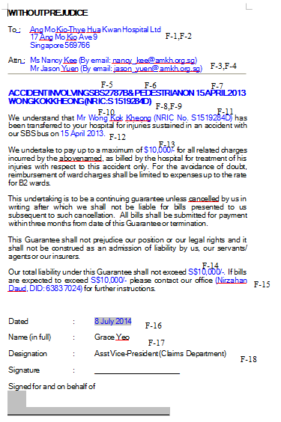

# LOG With Cancellation Clause for Previous LOG

|  |  |  |  |  |  |  |
| --- | --- | --- | --- | --- | --- | --- |
| **Form name** | LOG with cancellation clause for previous LOG | | |  |  |  |
| s.no. | Field number as per screen | Field names | screen Name | screen field name | EBIX Remarks | CDGI Remarks |
| 1 | F-1 | Hospital name | Unknown | Unknown | Prefix or where to pull from? | Additional field or tab for user to select which hospital or clinic claimant has visited Drop down field for user to select which hospital or clinic? |
| 2 | F-2 | Hospital address | Unknown | Unknown | Prefix or where to pull from? |
| 3 | F-3 | Attention : |  |  | To Be Prefixed? | "Attn: Business Office" > can be prefixed but the fax number needs to be populated from the additional fields. |
| 4 | F-4 | 1st party involved in accident | Accident | Vehicle No |  |  |
| 5 | F-5 | 2nd party involved in accident |  |  | To Be Prefixed? | Could be commuter too. To have a field to indicate the type of claimant, pedestrian or commuter. |
| 6 | F-6 | Accident date | Accident | Accident Date |  |  |
| 7 | F-7 | Insured name | Payment |  | Payee's Name & NRIC or where to pull from? | Additional field or tab for user to enter the 3rd party individual claimant's particulars, 3rd party workshops, lawyers, surveyors & insurers. The 3rd Party Reference No. will be entered by user in the 3rd party claimants, workshops, lawyers, surveyors & insurers. |
| 8 | F-8 | Insured name | Payment |  | Payee's Name or where to pull from? |
| 9 | F-9 | Patient nric number | Payment |  | Payee's NRIC or where to pull from? |
| 10 | F-10 | accident date | Accident | Accident Date |  |  |
| 11 | F-11 | Settlement amount | Payment | Local Currency |  | No, it is not the settlement amount. It is total amount of all the LOGs issued. |
| 12 | F-12 | Guarantee date | Accident | Accident Date |  | No. Guarantee date is not accident date. The claims department may issue more than 1 LOG to seriously wounded claimants. We will need to track all the LOGs issued (if any) for each claim. An additional field or table to capture all the LOGs issued? i.e. in the LOG tracking table there are N LOGs issued. The previous LOG date should be date of the N-1 of LOG issued in the LOG tracking table, where N is the S/N of the latest LOG entered into the table |
| 13 | F-13 | sattlement amount | Payment | Local Currency | Or To Be Prefixed? | Not settlement amount. Please see S/N 12. It is the total amount of all the LOGs issued in the LOG tracking table |
| 14 | F-14 | Sattlement amount | Payment | Local Currency | Or To Be Prefixed? | Same as S/N 13. |
| 15 | F-15 | office address |  |  |  | Claims Officer's ID and DID |
| 16 | F-16 | Field not confirm | Claim | Preview Documents | Date that Doc is generated? | Yes date the doc was generated. |
| 17 | F-17 | AVP name | User Admin | User | Prefixed or based on User ID who generated this Doc? | No. Based on the head of department's ID. |
| 18 | F-18 | designation | User Admin | Group | Prefixed or based on User ID who generated this Doc? |

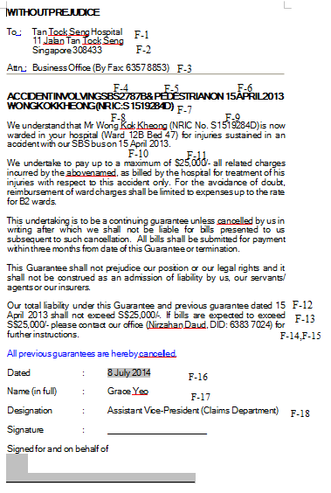

# Rule

|  |  |  |  |  |
| --- | --- | --- | --- | --- |
| **IF** | **Then** | **Else** | **And** | **Or** |
|  |  |  |  |  |
|  |  |  |  |  |

# Implementation

## Current Implementation

* Payment does not exist in application

## Targeted Implementation

* Payment Creation

# Change Required